
Connecting Excellence. Empowering Growth.
06a MANAGED DELIVERY
Ready Products Catalogue
كتالوج المنتجات الجاهزة
◆ ◆ ◆
WHAT THIS IS
Kayan's full range of services as fixed-scope, fixed-price products — choose, fund, and start.
A Yemeni operating institution ◆ Aden
Kayan Innovation, Entrepreneurship & Work Environments LLC
OWNER: CEO (MAHER FAISAL SAEED FAREA) · SALES ◆ SHAREABLE — CLIENT-FACING
Effective 30 June 2026

HOW IT OPERATES
WHAT THIS IS | Kayan's complete productised range — 35 ready-made offers across eight families, each a fixed scope at a fixed price, delivered by a managed pod under escrow.
WHO IT IS FOR | Every client Kayan serves — from an individual or a new founder, to a restaurant, a hotel, an SME, an NGO, a government body, or a businessman.
APPROVAL & ENDORSEMENT | Owned by the CEO and Sales; each order is confirmed and the price is held in escrow before any work begins.
WHEN IT IS USED | At the first client conversation, on the platform, and in every sales pitch — the fastest route from interest to a funded project.
WORKFLOW | Choose a product → fund 100% into escrow → the pod delivers and is QA-checked → 5-day review → acceptance releases payment.
COST / FEE | Prices are in USD and include the 20% Kayan net fee; converted to YER at the actual Aden rate on the day of payment.
OWNER & REVIEW | CEO / Sales. Reviewed quarterly; new products graduate from the Ideas Bank as demand and the verified bench allow.
01 IDEA

Choose. Fund. Start.
In a market where the hardest part of buying a service is trusting it will arrive, Kayan sells the trust pre-packaged.
In Aden today, commissioning professional work is an act of faith. Scope is argued over, prices are invented on the spot, deadlines slip, and there is rarely any recourse if the work never comes. The Ready Products Catalogue removes that friction entirely. Each product has a fixed scope, a fixed price, a named delivery date, and a managed team behind it — and every order is protected by escrow from the first day. The client does not negotiate a brief; they choose a product the way they would choose anything else they trust. This catalogue spans thirty-five products, from a USD 280 voice-over to a USD 5,500 custom platform, so that whoever walks through the door — an individual, a founder, a café, a hotel, an NGO, or a businessman — finds something built precisely for them.
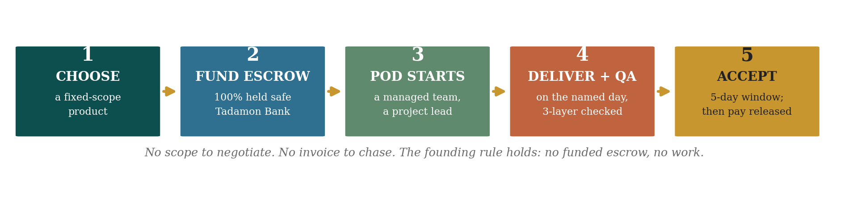
FIGURE ◆ Five steps from a decision to a delivered result — the same trust gate behind every product.
02 PROMISE

What Every Product Guarantees
A Ready Product is never just a price. Behind each one stands the full Kayan machinery — the same gates, the same verified pods, the same escrow that protects a six-figure managed-delivery contract. Six things are true of every product in this catalogue.
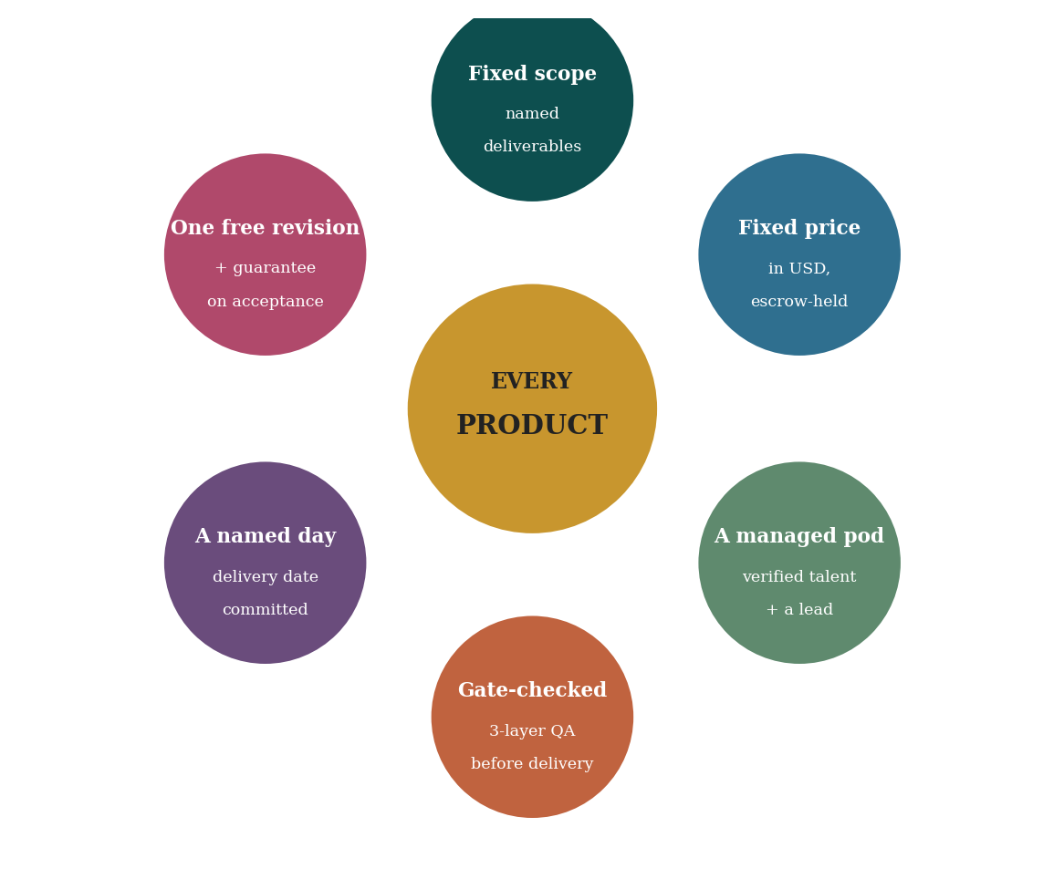
FIGURE ◆ Whatever the client buys, this is what sits behind the price.
03 FAMILIES

Eight Families, One Institution
The catalogue is organised into eight families so a client can find their need at a glance. Brand & Creative and the recurring lines run under Kayan Studio; the build and project lines under Kayan Managed Delivery; research and evaluation under a dedicated data practice; and the enterprise suites bring several products together for hotels, serious restaurants, and business leaders. All families run on the same pods, gates, escrow, and the Kayan Card.
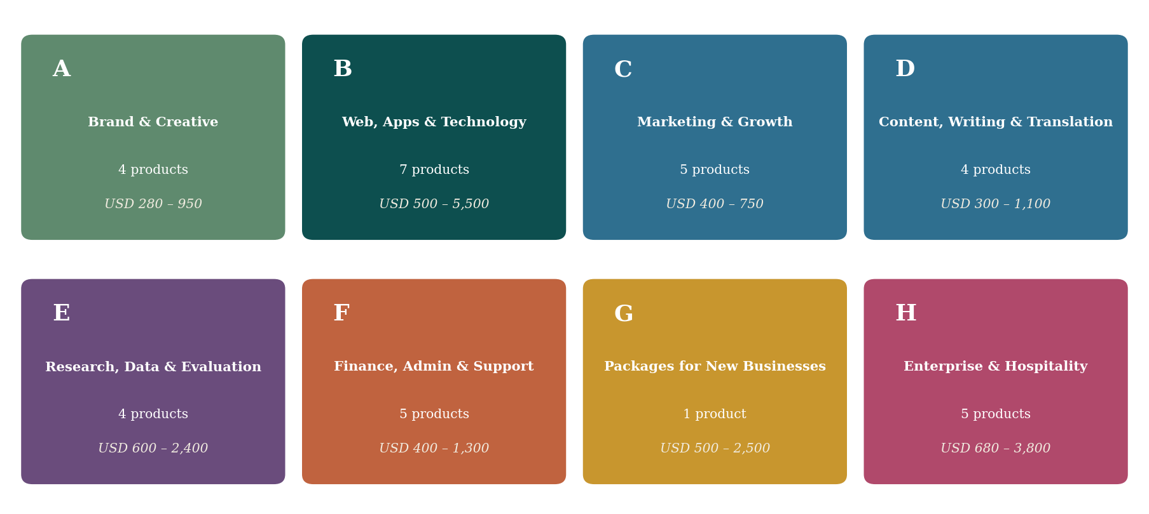
FIGURE ◆ Eight families, thirty-five products — colour-coded throughout this catalogue.
04 RANGE

The Full Range
Products span USD 280 to USD 5,500 — deliberately, so a cautious first client can start small, see the gates and the guarantee work once, and climb. The first completed product is rarely about its fee; it is the verified delivery record that earns the next, larger commission.
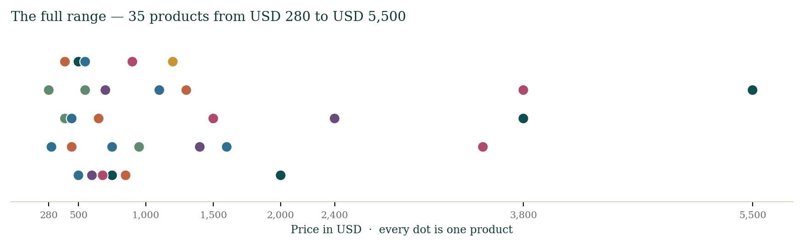
FIGURE ◆ Every dot is one product — the full price range at a glance.

05 THE CATALOGUE

The Catalogue
Thirty-five products across eight families — each a complete promise: the team, the time, the deliverables, and what each dollar buys.
Code | Product | Price USD | Family
RP-001 | Brand Identity Pack | 500 | Brand & Creative
RP-016 | Brand Refresh & Rebrand | 950 | Brand & Creative
RP-020 | Video & Motion Pack | 650 | Brand & Creative
RP-031 | Voice-Over & Audio | 280 | Brand & Creative
RP-002 | Professional Website | 1,200 | Web, Apps & Technology
RP-008 | MVP Web Application | 2,000 | Web, Apps & Technology
RP-017 | E-commerce Storefront | 1,600 | Web, Apps & Technology
RP-021 | Mobile App (iOS & Android) | 3,800 | Web, Apps & Technology
RP-022 | Custom Web Platform | 5,500 | Web, Apps & Technology
RP-023 | IT & DevOps Care (Retainer) | 500 / mo | Web, Apps & Technology
RP-024 | AI Automation & Chatbot | 750 | Web, Apps & Technology
RP-003 | Launch Marketing Pack | 750 | Marketing & Growth
RP-004 | Monthly Content Pack (Retainer) | 400 / mo | Marketing & Growth
RP-009 | Social Media Management (Retainer) | 550 / mo | Marketing & Growth
RP-029 | SEO Launch & Optimization | 550 | Marketing & Growth
RP-030 | Paid Ads Management (Retainer) | 500 / mo * | Marketing & Growth
RP-005 | Professional Translation | 300 | Content, Writing & Translation
RP-007 | Corporate Documents Pack | 450 | Content, Writing & Translation
RP-018 | Annual Report (Design + Write) | 1,100 | Content, Writing & Translation
RP-012 | NGO Report & Proposal Pack | 900 | Content, Writing & Translation
RP-006 | Market Study | 600 | Research, Data & Evaluation
RP-013 | Data Collection & Dashboard | 1,400 | Research, Data & Evaluation
RP-014 | Monitoring & Evaluation Study | 2,400 | Research, Data & Evaluation
RP-015 | Pitch Deck & Investor Pack | 700 | Research, Data & Evaluation
RP-025 | Bookkeeping & Accounting (Retainer) | 400 / mo | Finance, Admin & Support
RP-026 | Financial Model & Projections | 850 | Finance, Admin & Support
RP-027 | Virtual Assistant (Retainer) | 450 / mo | Finance, Admin & Support
RP-028 | Customer Service Desk (Retainer) | 650 / mo | Finance, Admin & Support
RP-019 | Training Workshop (Design + Deliver) | 1,300 | Finance, Admin & Support
RP-032 | Startup-in-a-Box | 500 / 1,200 / 2,500 | Packages for New Businesses
RP-010 | Restaurant Launch Kit | 680 | Enterprise & Hospitality
RP-033 | Enterprise Restaurant Suite | 3,500 | Enterprise & Hospitality
RP-011 | Hotel Digital Presence | 1,500 | Enterprise & Hospitality
RP-034 | Hotel Revenue Suite | 3,800 | Enterprise & Hospitality
RP-035 | Executive & Personal Brand | 900 | Enterprise & Hospitality

FAMILY A
Brand & Creative
The work that makes a business look and sound like itself.

RP-001 USD 500
Brand Identity Pack
SMEs, startups

Delivery | Team (Pod) | What it solves
14 days | Designer T2+ · QA | New ventures look improvised and untrustworthy
WHAT YOU RECEIVE
◂ Primary logo + 3 alternates (AI/PNG/SVG/PDF)
◂ Brand guide — colour, type, usage rules
◂ Stationery — card, letterhead, envelope, e-signature
◂ Print + digital files
◂ One free revision
EACH DOLLAR BUYS: A complete, ownable identity for less than one month of a junior hire
◆ ◆ ◆
RP-016 USD 950
Brand Refresh & Rebrand
Established SMEs

Delivery | Team (Pod) | What it solves
21 days | Designer T3+ · Strategist · QA | An ageing brand undercuts a growing business
WHAT YOU RECEIVE
◂ Brand audit
◂ Refreshed logo system
◂ Expanded palette + type
◂ Messaging lines (AR/EN)
◂ Applied templates (social, docs, signage)
◂ Rollout guide
EACH DOLLAR BUYS: A modern, consistent brand that matches where the business is now
◆ ◆ ◆
RP-020 USD 650
Video & Motion Pack
SMEs, NGOs, restaurants

Delivery | Team (Pod) | What it solves
14 days | Editor T2+ · Motion · Writer | Static posts are ignored; no video skills in-house
WHAT YOU RECEIVE
◂ 1 brand/promo video (60–90s)
◂ 4 short vertical social cuts
◂ Subtitles AR/EN
◂ Motion logo sting
◂ Licence-safe music
EACH DOLLAR BUYS: Scroll-stopping video — the single highest-engagement format
◆ ◆ ◆
RP-031 USD 280
Voice-Over & Audio
SMEs, media, NGOs

Delivery | Team (Pod) | What it solves
7 days | Voice artist T2+ · Audio editor | Videos and ads need a professional voice; phone recordings sound cheap
WHAT YOU RECEIVE
◂ Professional voice-over (AR/EN, up to 3 min)
◂ Script polish
◂ Clean mastered audio
◂ Licence-safe music bed
◂ 2 formats; 1 revision
EACH DOLLAR BUYS: A broadcast-quality voice that makes content sound professional
◆ ◆ ◆

FAMILY B
Web, Apps & Technology
From a first website to a published app to a platform built around you.

RP-002 USD 1,200
Professional Website
SMEs, NGOs

Delivery | Team (Pod) | What it solves
21 days | Dev T2+ · UI · Writer · QA | No credible online presence; clients/donors can't find or verify
WHAT YOU RECEIVE
◂ Responsive 5–7 page bilingual site (AR-RTL/EN)
◂ Custom design
◂ Basic SEO
◂ SSL + year-1 hosting
◂ CMS training (1h)
◂ Two revisions
EACH DOLLAR BUYS: A bilingual, credible web presence — the price of one overseas mock-up
◆ ◆ ◆
RP-008 USD 2,000
MVP Web Application
Startups, funded ventures

Delivery | Team (Pod) | What it solves
30 days | Full-stack T3+ · UI/UX · QA · PM | An idea can't be tested or shown to investors without a working product
WHAT YOU RECEIVE
◂ Responsive web app (5–8 screens)
◂ Login + user management
◂ Database + admin dashboard
◂ Custom UI/UX
◂ Testing + bug-fix
◂ Technical docs + initial deployment
EACH DOLLAR BUYS: A working, demoable product — a fraction of an overseas dev-shop quote
◆ ◆ ◆
RP-017 USD 1,600
E-commerce Storefront
Retailers, producers

Delivery | Team (Pod) | What it solves
25 days | Dev T2+ · UI · Writer · QA | Sellers depend on WhatsApp orders; no real storefront, no scale
WHAT YOU RECEIVE
◂ Online store (up to 30 products)
◂ Local payment / COD + delivery options
◂ Bilingual
◂ Product photo editing (30)
◂ Admin training
◂ Launch promo set
EACH DOLLAR BUYS: A real online store that takes orders while the owner sleeps
◆ ◆ ◆
RP-021 USD 3,800
Mobile App (iOS & Android)
Startups, funded ventures, gov

Delivery | Team (Pod) | What it solves
45 days | Mobile dev T3+ · UI/UX · QA · PM | An idea needs a real mobile app to reach customers; overseas quotes top $10k
WHAT YOU RECEIVE
◂ Cross-platform app, iOS + Android (up to 10 screens)
◂ User accounts + push notifications
◂ Backend API + admin panel
◂ App-store submission (both stores)
◂ Bilingual
◂ Testing + 30-day post-launch support
EACH DOLLAR BUYS: A published, store-ready app on both platforms — a fraction of a studio quote
◆ ◆ ◆
RP-022 USD 5,500
Custom Web Platform
Scaling firms, NGOs, gov

Delivery | Team (Pod) | What it solves
8–12 weeks | Full-stack T4 · UI/UX · QA · PM | A growing organisation needs a real system built around its process
WHAT YOU RECEIVE
◂ Bespoke platform with custom workflows
◂ Multi-role user management
◂ Integrations (payment / SMS / maps)
◂ Admin dashboard + reporting
◂ Bilingual
◂ Documentation + training
◂ Deployment + 60-day support
EACH DOLLAR BUYS: A platform built around how you actually work — owned, not rented
◆ ◆ ◆
RP-023 USD 500 / mo
IT & DevOps Care (Retainer)
Any site/app owner

Delivery | Team (Pod) | What it solves
Monthly | DevOps T3+ · Support | Sites and apps break and nobody maintains them; downtime loses revenue
WHAT YOU RECEIVE
◂ Hosting + domain management
◂ Uptime monitoring
◂ Weekly backups
◂ Security updates
◂ Bug-fix hours (up to 8/mo)
◂ Monthly health report
EACH DOLLAR BUYS: A site that stays up, secure, and current — peace of mind, monthly
◆ ◆ ◆
RP-024 USD 750
AI Automation & Chatbot
SMEs, restaurants, clinics

Delivery | Team (Pod) | What it solves
14 days | Developer T2+ · Content · QA | Owners answer the same messages all day; leads slip at night
WHAT YOU RECEIVE
◂ WhatsApp or web chatbot (bilingual)
◂ FAQ + lead-capture flows
◂ 1 workflow automation (e.g. orders/bookings to a sheet)
◂ Handover-to-human
◂ Setup + training
EACH DOLLAR BUYS: A tireless assistant that answers and captures leads 24/7
◆ ◆ ◆

FAMILY C
Marketing & Growth
Getting found, getting followed, and getting chosen.

RP-003 USD 750
Launch Marketing Pack
SMEs, startups

Delivery | Team (Pod) | What it solves
14 days | Marketer T2+ · Designer · Writer | Launches land silently; no audience, wasted opening window
WHAT YOU RECEIVE
◂ 10-page launch strategy
◂ 15 social posts (design+copy, AR/EN)
◂ 3-platform account setup
◂ Email template + 3 drafts
◂ Competitor analysis
EACH DOLLAR BUYS: A full launch campaign and a 3-platform presence ready on day one
◆ ◆ ◆
RP-004 USD 400 / mo
Monthly Content Pack (Retainer)
SMEs, retailers

Delivery | Team (Pod) | What it solves
Monthly | Writer T2+ · Designer | Brands go quiet after launch; no time to stay visible
WHAT YOU RECEIVE
◂ 8 social posts (design+copy)
◂ 1 blog article (800–1,200w)
◂ Monthly newsletter
◂ Simple performance report
◂ Next-month content calendar
EACH DOLLAR BUYS: An always-on content team for a fraction of one part-time salary
◆ ◆ ◆
RP-009 USD 550 / mo
Social Media Management (Retainer)
Restaurants, retailers, clinics

Delivery | Team (Pod) | What it solves
Monthly | Marketer T2+ · Designer · Writer | Owner runs social personally and inconsistently
WHAT YOU RECEIVE
◂ 16 posts/mo (design+copy AR/EN)
◂ 2 platforms managed
◂ Community-reply guidance
◂ Monthly ads-ready creative set
◂ 1 boosted-post setup
◂ Monthly report
EACH DOLLAR BUYS: A managed social presence that actually grows followers and footfall
◆ ◆ ◆
RP-029 USD 550
SEO Launch & Optimization
SMEs with a site

Delivery | Team (Pod) | What it solves
14 days | SEO specialist T2+ · Writer | A site exists but nobody finds it; invisible on Google
WHAT YOU RECEIVE
◂ Technical SEO audit + fixes
◂ Keyword research (AR/EN)
◂ On-page optimization (up to 10 pages)
◂ Google Business + Maps
◂ Analytics + Search Console
◂ 90-day action plan
EACH DOLLAR BUYS: Found by the customers already searching for you
◆ ◆ ◆
RP-030 USD 500 / mo *
Paid Ads Management (Retainer)
SMEs, e-commerce

Delivery | Team (Pod) | What it solves
Monthly | Ads specialist T2+ · Designer | Owners boost posts randomly and waste money
WHAT YOU RECEIVE
◂ Campaign setup (Meta / Google)
◂ 4 ad creatives/mo
◂ Audience targeting
◂ Budget management
◂ A/B testing
◂ Monthly performance report
EACH DOLLAR BUYS: Every ad dollar measured and optimised — not guessed (ad spend billed separately)
◆ ◆ ◆

FAMILY D
Content, Writing & Translation
Words that carry weight — in both languages.

RP-005 USD 300
Professional Translation
NGOs, companies

Delivery | Team (Pod) | What it solves
7 days | Translator T2+ · Reviewer | Reports/proposals fail in the other language
WHAT YOU RECEIVE
◂ Up to 10,000 words AR↔EN
◂ Second-translator review
◂ Final formatting (PDF+Word)
◂ Client glossary
◂ One free revision
EACH DOLLAR BUYS: Donor-grade bilingual documents, reviewed twice, in a week
◆ ◆ ◆
RP-007 USD 450
Corporate Documents Pack
SMEs, NGOs

Delivery | Team (Pod) | What it solves
10 days | Writer T2+ · Designer · Reviewer | Organisation can't present itself professionally
WHAT YOU RECEIVE
◂ Company profile (AR+EN)
◂ 15–20 slide presentation
◂ 5 correspondence templates
◂ 3 report templates
◂ Unified brand-aligned design
EACH DOLLAR BUYS: A complete document kit that makes a small team look established
◆ ◆ ◆
RP-018 USD 1,100
Annual Report (Design + Write)
NGOs, companies

Delivery | Team (Pod) | What it solves
18 days | Writer T3+ · Designer · Translator | Annual reports are rushed and ugly; a missed credibility moment
WHAT YOU RECEIVE
◂ Narrative writing/editing (up to 30 pages)
◂ Data-visualisation
◂ Bilingual layout
◂ Print + digital
◂ Executive summary
◂ 2 revisions
EACH DOLLAR BUYS: A flagship report that makes the year's work look as good as it was
◆ ◆ ◆
RP-012 USD 900
NGO Report & Proposal Pack
NGOs, INGOs

Delivery | Team (Pod) | What it solves
12 days | Writer T3+ · Designer · Translator · QA | Strong content in weak layout loses to better-presented bids
WHAT YOU RECEIVE
◂ Donor-ready report or proposal (up to 40 pages, AR/EN)
◂ Data-visualisation of results
◂ Branded layout to donor template
◂ Executive summary
◂ 2 revisions
EACH DOLLAR BUYS: A donor-grade document that competes on presentation, not just content
◆ ◆ ◆

FAMILY E
Research, Data & Evaluation
Evidence a founder, an investor, or a donor can trust.

RP-006 USD 600
Market Study
Startups, investors

Delivery | Team (Pod) | What it solves
14 days | Researcher T3+ · Analyst · QA | Founders commit capital on hunches; no evidence base
WHAT YOU RECEIVE
◂ 20–30 page market analysis
◂ 5–10 competitor analysis
◂ Target-audience analysis
◂ Strategic recommendations
◂ 3-page executive summary
◂ Findings presentation
EACH DOLLAR BUYS: An evidence base for a major decision — cheaper than one wrong hire
◆ ◆ ◆
RP-013 USD 1,400
Data Collection & Dashboard
NGOs, INGOs, gov

Delivery | Team (Pod) | What it solves
21 days | Data analyst T3+ · Field lead · QA | MEAL teams lack surge capacity for collection + clean data + a dashboard
WHAT YOU RECEIVE
◂ KoBo/ODK form design
◂ Enumerator training (1 day)
◂ Supervised collection (sample up to 400)
◂ Cleaned dataset
◂ Live dashboard (PowerBI/Looker)
◂ Findings brief
EACH DOLLAR BUYS: Defensible field data and a live dashboard — TPM quality, locally delivered
◆ ◆ ◆
RP-014 USD 2,400
Monitoring & Evaluation Study
NGOs, INGOs

Delivery | Team (Pod) | What it solves
30 days | M&E lead T4 · Analyst · QA | Donors require independent evaluation; few credible local providers
WHAT YOU RECEIVE
◂ Evaluation design (logframe-aligned)
◂ Tools
◂ Mixed-method data collection
◂ Analysis
◂ Full evaluation report (AR/EN)
◂ Validation workshop
◂ Presentation
EACH DOLLAR BUYS: An independent, donor-grade evaluation delivered from inside Yemen
◆ ◆ ◆
RP-015 USD 700
Pitch Deck & Investor Pack
Startups, SMEs raising

Delivery | Team (Pod) | What it solves
12 days | Writer T3+ · Designer · Analyst | Founders can't translate a business into an investable story
WHAT YOU RECEIVE
◂ Investor pitch deck (12–16 slides, AR/EN)
◂ 1-page teaser
◂ Simple 3-yr financial model
◂ Data-room checklist
◂ Rehearsal notes
EACH DOLLAR BUYS: An investor-ready story and model — the difference between a meeting and a pass
◆ ◆ ◆

FAMILY F
Finance, Admin & Support
The back-office a small team cannot afford to hire — on a monthly footing.

RP-025 USD 400 / mo
Bookkeeping & Accounting (Retainer)
SMEs

Delivery | Team (Pod) | What it solves
Monthly | Bookkeeper T2+ · Reviewer | SMEs keep books in a drawer; no clarity, painful at tax time
WHAT YOU RECEIVE
◂ Monthly books (up to 100 transactions)
◂ Bank reconciliation
◂ VAT-ready summaries
◂ Simple P&L + cash report
◂ Receipts organised
◂ Year-end pack
EACH DOLLAR BUYS: Clean, current books and a clear monthly picture of the business
◆ ◆ ◆
RP-026 USD 850
Financial Model & Projections
Startups, SMEs, founders

Delivery | Team (Pod) | What it solves
14 days | Financial modeler T3+ · Analyst · QA | Founders can't answer 'what are your numbers?'
WHAT YOU RECEIVE
◂ 3-year financial model (revenue, costs, cash)
◂ 3 scenarios
◂ Assumptions sheet
◂ Break-even + key ratios
◂ Investor-ready summary
◂ Walkthrough
EACH DOLLAR BUYS: The numbers behind the story — ready for a bank or an investor
◆ ◆ ◆
RP-027 USD 450 / mo
Virtual Assistant (Retainer)
Owners, executives

Delivery | Team (Pod) | What it solves
Monthly | VA T2+ | Owners drown in admin instead of growing the business
WHAT YOU RECEIVE
◂ Up to 40 hours/mo remote admin
◂ Inbox + calendar management
◂ Data entry
◂ Document formatting
◂ Research
◂ Weekly check-in
EACH DOLLAR BUYS: Forty hours of your time back, every month
◆ ◆ ◆
RP-028 USD 650 / mo
Customer Service Desk (Retainer)
Retailers, e-commerce, clinics

Delivery | Team (Pod) | What it solves
Monthly | Support agents T2+ · Lead | Messages go unanswered; customers feel ignored
WHAT YOU RECEIVE
◂ Managed WhatsApp/social/email support (business hours)
◂ Response within SLA
◂ Order/enquiry handling
◂ Bilingual
◂ Escalation rules
◂ Monthly satisfaction report
EACH DOLLAR BUYS: Every customer answered fast, bilingually — without hiring a team
◆ ◆ ◆
RP-019 USD 1,300
Training Workshop (Design + Deliver)
NGOs, companies, gov

Delivery | Team (Pod) | What it solves
Per cohort | Trainer T4 · Designer · Coordinator | Teams need capability; external trainers fly in at high cost and leave nothing
WHAT YOU RECEIVE
◂ Curriculum design
◂ Bilingual materials + slides
◂ 2-day facilitated workshop (up to 20)
◂ Workbooks
◂ Certificates
◂ Post-workshop report
EACH DOLLAR BUYS: A capability your team keeps — designed and delivered locally
◆ ◆ ◆

FAMILY G
Packages for New Businesses
Everything a new company needs, in one decision.

RP-032 USD 500 / 1,200 / 2,500
Startup-in-a-Box
People establishing new companies

Delivery | Team (Pod) | What it solves
10–30 days | Multi-role pod · PM | New founders must assemble a brand, site, and presence from scratch under pressure
WHAT YOU RECEIVE
◂ ESSENTIALS ($500): logo + business card + 3-page website + social setup (2 platforms) + 1-month content calendar
◂ PROFESSIONAL ($1,200): + full brand guidelines, 7-page website with CMS, email setup, letterhead + invoice templates, pitch deck, 3-month content plan
◂ PREMIUM ($2,500): + marketing strategy, competitor analysis, CRM setup, 6-month social management, monthly reporting
EACH DOLLAR BUYS: A business that looks established from its first day — in one decision
◆ ◆ ◆

FAMILY H
Enterprise & Hospitality
Complete suites for hotels, serious restaurants, and the people who lead them.

RP-010 USD 680
Restaurant Launch Kit
Restaurants, cafés

Delivery | Team (Pod) | What it solves
18 days | Designer T2+ · Writer · Photographer* | New venues open with phone-photo menus and no delivery-app presence
WHAT YOU RECEIVE
◂ Menu design (print + digital/QR, AR/EN)
◂ 30 food-photo edits
◂ Table-talkers + signage
◂ Delivery-app profile setup
◂ Opening social pack (10 posts)
EACH DOLLAR BUYS: A fully branded, delivery-ready launch — everything a guest sees, done right
◆ ◆ ◆
RP-033 USD 3,500
Enterprise Restaurant Suite
Big / multi-branch restaurants

Delivery | Team (Pod) | What it solves
35 days | Designer T3 · Dev · Photographer · Marketer · PM | A serious or multi-branch restaurant needs a complete, consistent presence everywhere
WHAT YOU RECEIVE
◂ Full brand system (multi-branch ready)
◂ Bilingual website with menu + reservations
◂ 60 professional food-photo edits
◂ Delivery-app setup across platforms
◂ QR + print menus
◂ 3-month social management
◂ Signage system
◂ Loyalty-card concept
EACH DOLLAR BUYS: One coherent brand across every branch, platform, and plate
◆ ◆ ◆
RP-011 USD 1,500
Hotel Digital Presence
Hotels, guesthouses

Delivery | Team (Pod) | What it solves
24 days | Dev T2+ · UI · Writer · Photographer* | Hotels rely on walk-ins; invisible online; no direct-enquiry channel
WHAT YOU RECEIVE
◂ Bilingual hotel site with room showcase + enquiry form
◂ 40 property-photo edits
◂ Google Business Profile setup
◂ 3 OTA listing profiles (copy+photos)
◂ Review-response playbook
EACH DOLLAR BUYS: A direct booking channel and a credible presence where guests look
◆ ◆ ◆
RP-034 USD 3,800
Hotel Revenue Suite
Larger hotels

Delivery | Team (Pod) | What it solves
35 days | Dev T3 · UI · Photographer · Marketer · PM | A larger hotel leaves money on the table with no direct channel and poor OTA presence
WHAT YOU RECEIVE
◂ Multilingual site with booking-request engine
◂ 60 property-photo edits
◂ Google Business + 4 OTA listings managed
◂ Review-management system
◂ 3-month social
◂ Email-enquiry automation
◂ Rate-display setup
EACH DOLLAR BUYS: A direct booking channel plus a managed presence everywhere guests look
◆ ◆ ◆
RP-035 USD 900
Executive & Personal Brand
Businessmen, leaders

Delivery | Team (Pod) | What it solves
14 days | Writer T3 · Designer · Marketer | A leader has no credible personal presence; invisible to partners and media
WHAT YOU RECEIVE
◂ Personal brand strategy
◂ LinkedIn profile rewrite + banner
◂ Professional bio (AR/EN, 3 lengths)
◂ One-page media kit
◂ Headshot direction
◂ 10 thought-leadership post drafts
◂ Personal 1-page website
EACH DOLLAR BUYS: A leader who looks the part online — to partners, press, and investors
◆ ◆ ◆

06 MONEY

Where the Money Goes
Because the products are productised, the economics are transparent — and the same on every order. The client funds the full price into escrow at the Tadamon Islamic Bank before work begins. That money is never Kayan's revenue; it is the talent's, held safe until the work is accepted. On acceptance, the talent is paid 80%, Kayan recognises only its 20% net fee, and a 2% holdback is kept for 30 days against any defect, then released.
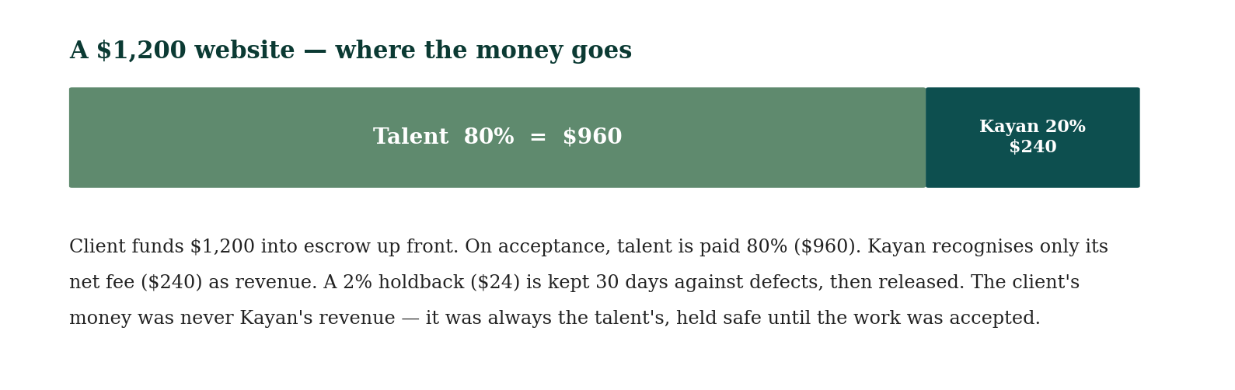
FIGURE ◆ A worked example — the USD 1,200 website, and exactly where each dollar goes.
07 RULES

The Rules of the Catalogue
◆ Choose a tier where one exists. Several products (Website, Brand Identity, Social Media, Startup-in-a-Box, Market Study) come in Good / Better / Best tiers so a client can match the scope to the budget.
◆ One free revision is included unless the product states more. Further revisions are 20% of the product price.
◆ Acceptance is a 5-business-day window. Acceptance releases payment; silence within the window is deemed acceptance.
◆ Prices are in USD and held firm; payment in YER converts at the actual Aden rate on the day, recorded against the dated rate table — never a notional rate.
◆ Retainers are billed monthly in advance; rush delivery is +10% (it accelerates the pod, never skips a gate); and the founding rule is absolute — no signed order and no funded escrow means no work.
A product is the beginning of a relationship, not the end of a transaction: a Brand Identity leads to a Website and a Bookkeeping retainer; a Market Study leads to a Pitch Pack, an MVP, and a raise; a Restaurant Launch Kit grows into the Enterprise Suite. The catalogue is the front door; the managed-delivery engine is the house.
Connected Systems & Instruments
Managed Delivery Operating Standard (KAY-OPS-MD-001) ◆ Revenue Architecture (KAY-FIN-REV-001) ◆ Financial Policy & escrow (KAY-FIN-POL-001) ◆ Service Intake & SOW (KAY-CON-002) ◆ Refund & Cancellation Policy (KAY-CON-004) ◆ Freelancer Registry & the Kayan Card (KAY-TAL-REG-001) ◆ Products & Ideas Engine (KAY-CLT-006-ENGINE).
◆

